**SCREENSHOTS**

**FIG 1:**

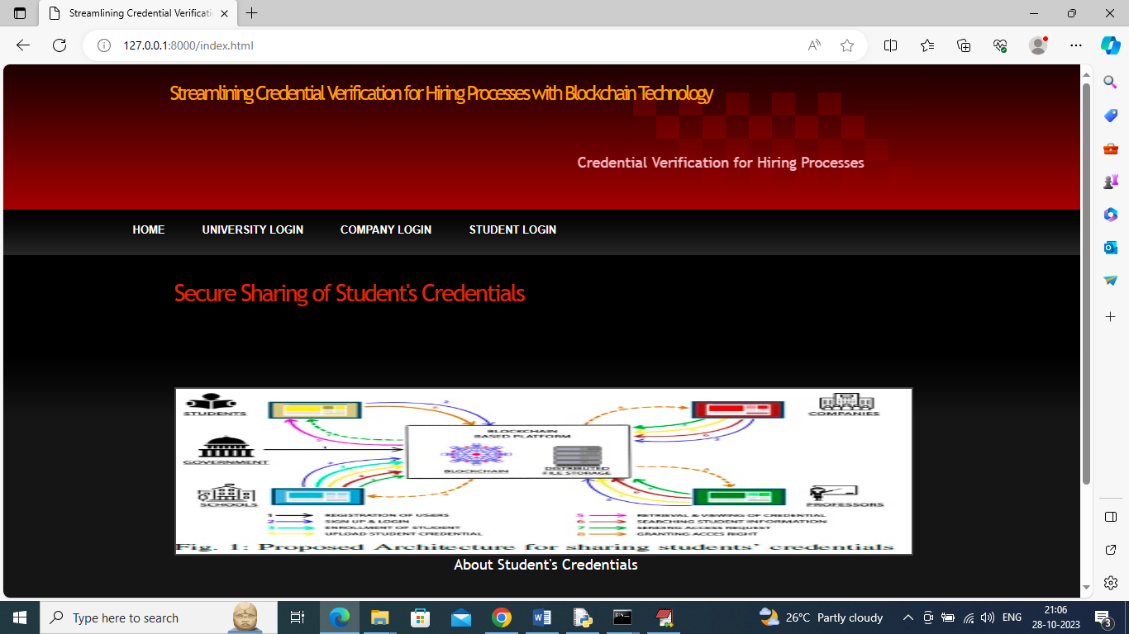

In above screen click on ‘University Login’ link to get below page

**FIG 2:**

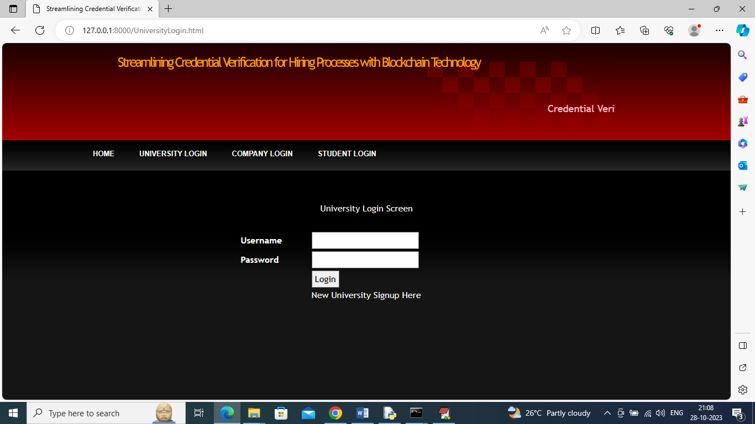

In above screen click on ‘New University Signup Here’ link to get below signup page

**FIG 3:**

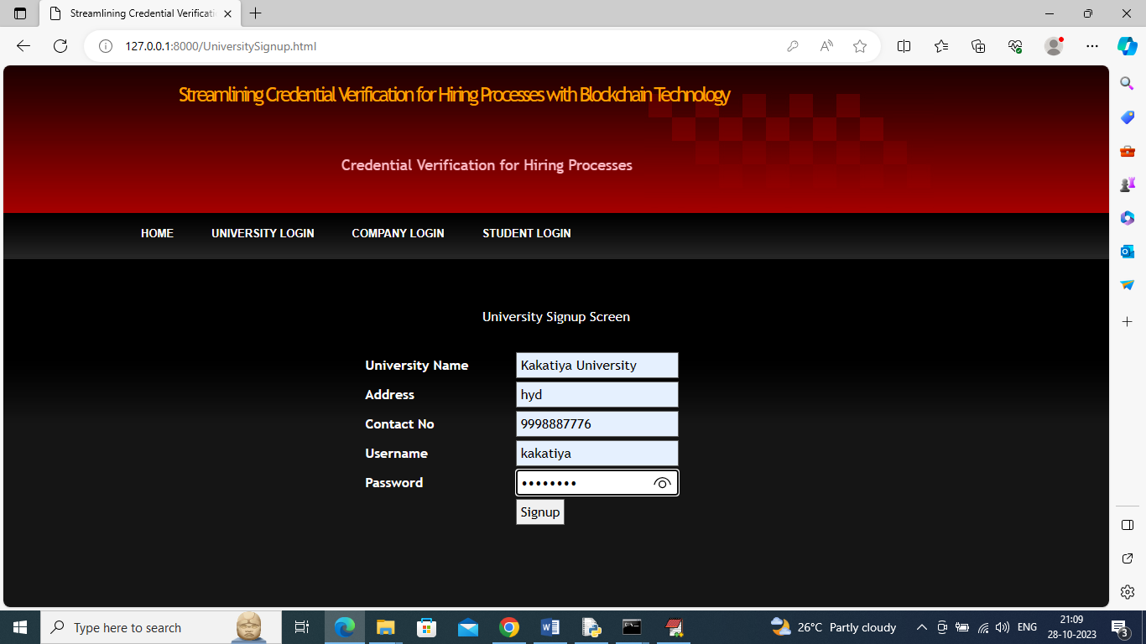

In above screen adding university signup details and then press button to save details in Blockchain and get below page

**FIG 4:**

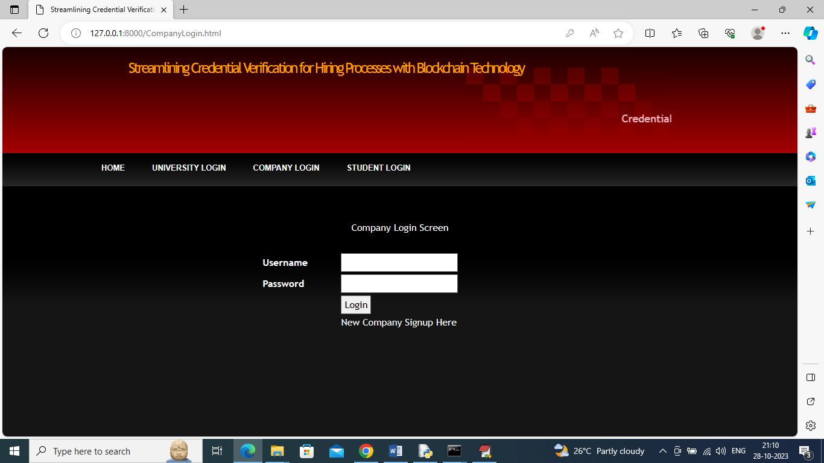

In above screen click on ‘New Company Signup Here’ link to get below company signup screen

**FIG 5:**

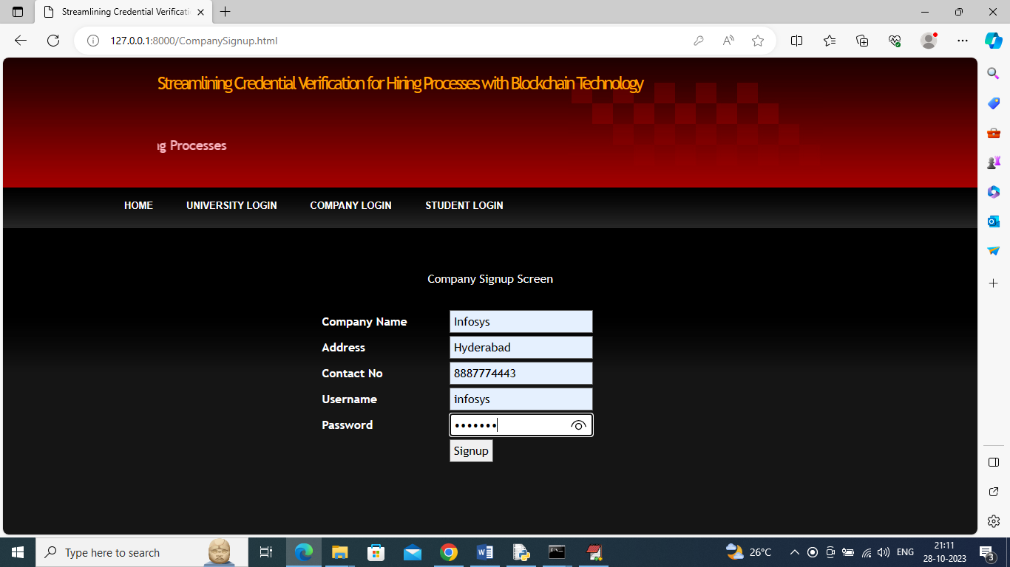

In above screen adding company details and then press button to save company details in Ethereum and get below page

**FIG 6:**

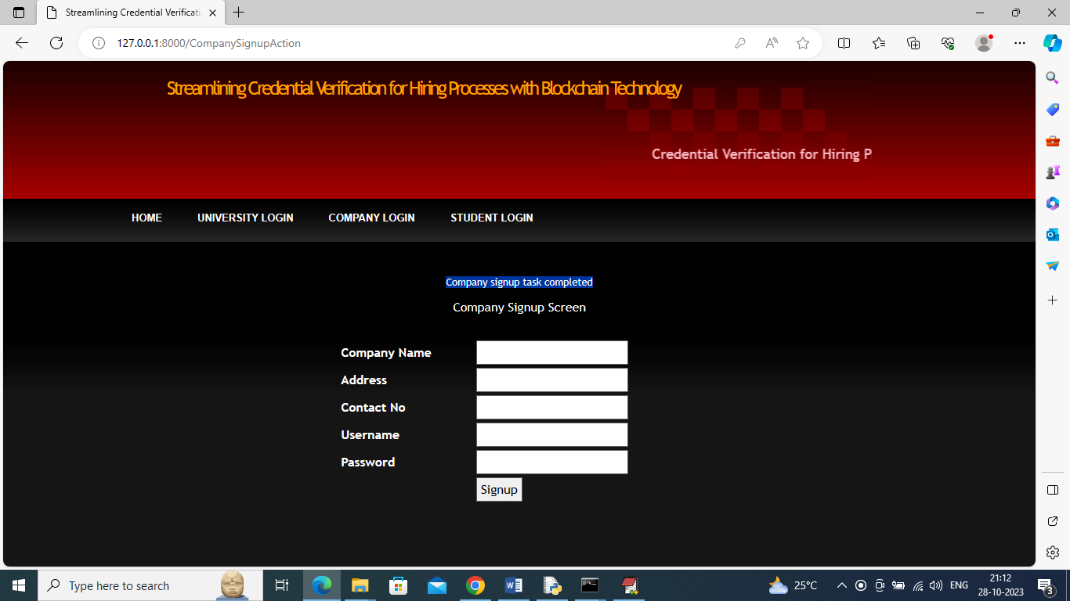

In above Screen Company signup completed and now click on ‘University Login’ link to get below page

**FIG 7:**

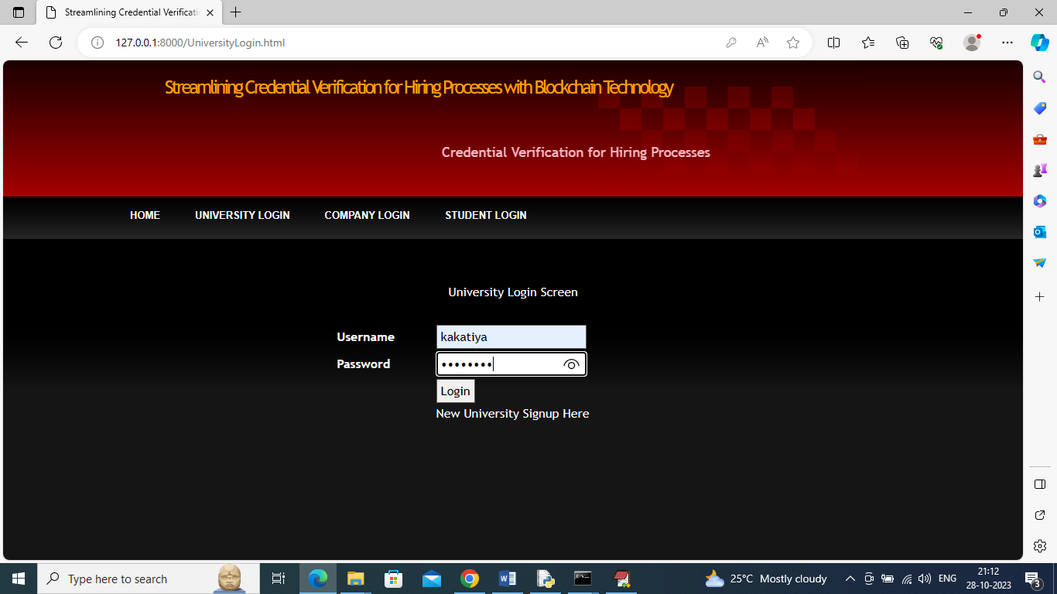

In above screen university is login and after login will get below page

**FIG 8:**

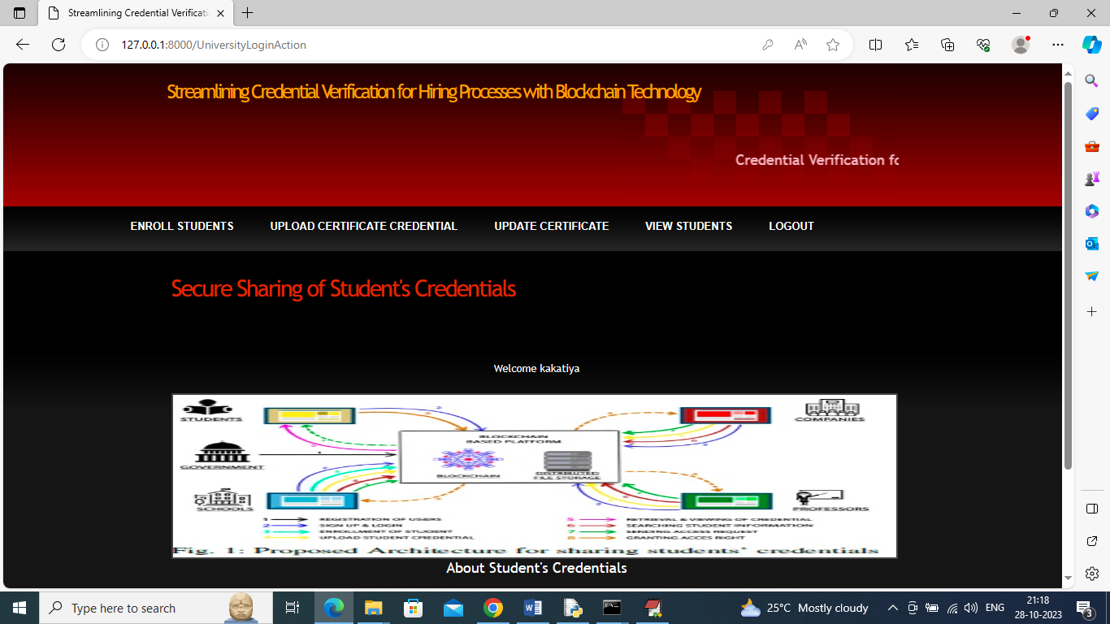

In above screen university can click on ‘Enrol Student’ link to add student details in Ethereum

**FIG 9:**

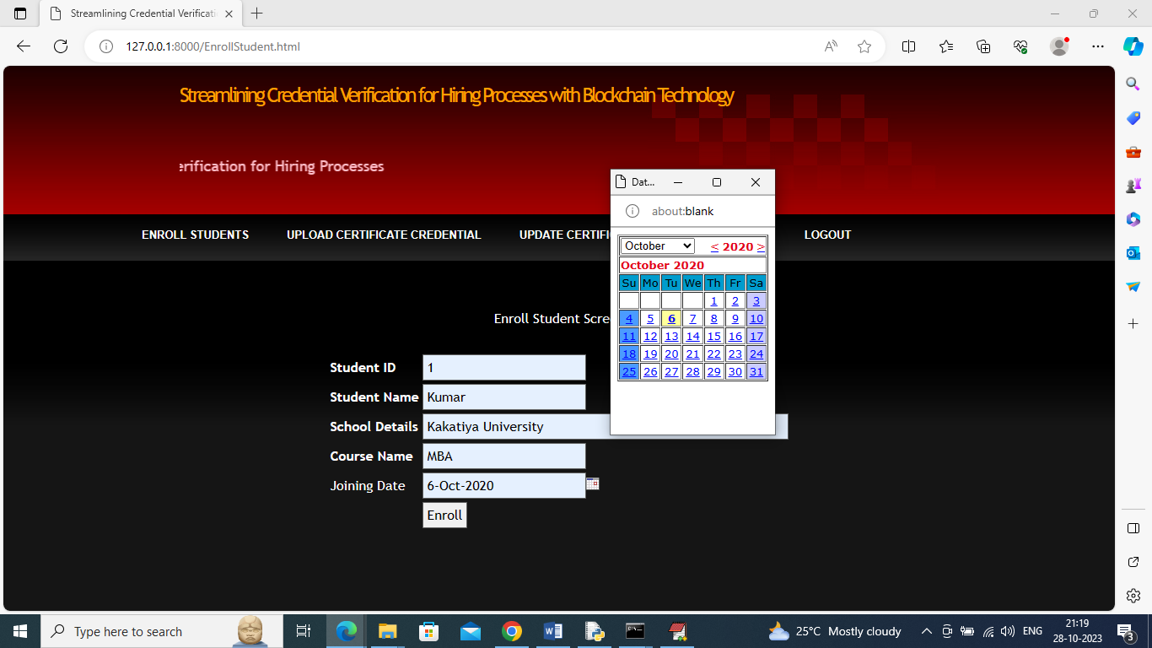

In above screen university is adding student details and then click on ‘Enrol’ button to save student details in Ethereum

**FIG 10:**

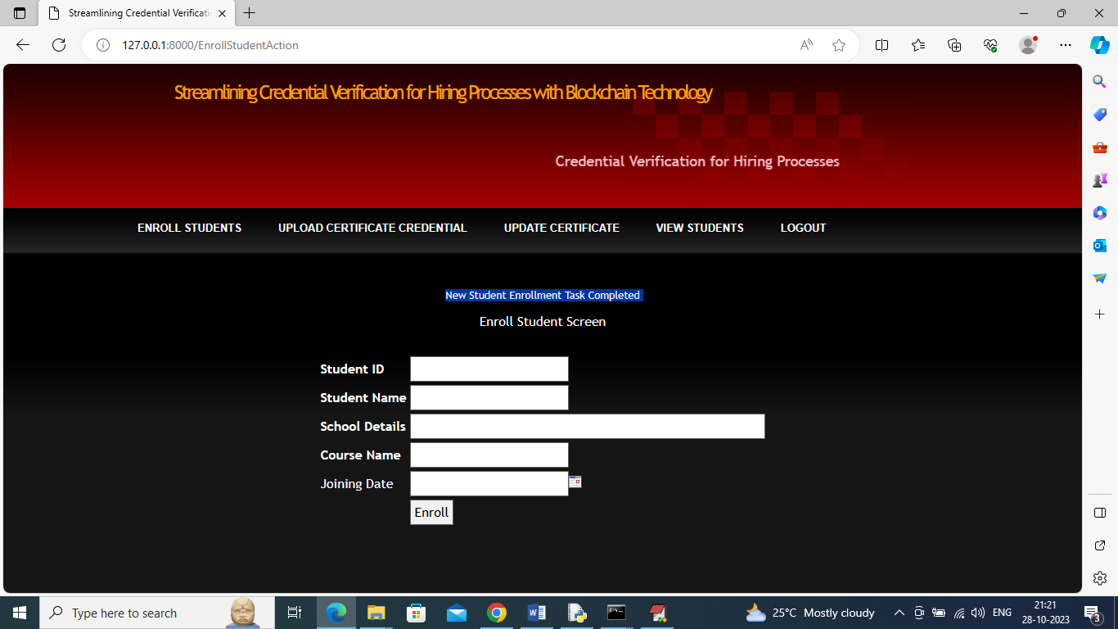

In above screen student details added and university can click on ‘Upload Certificate Credential’ link to upload student certificates in Blockchain

**FIG 11:**

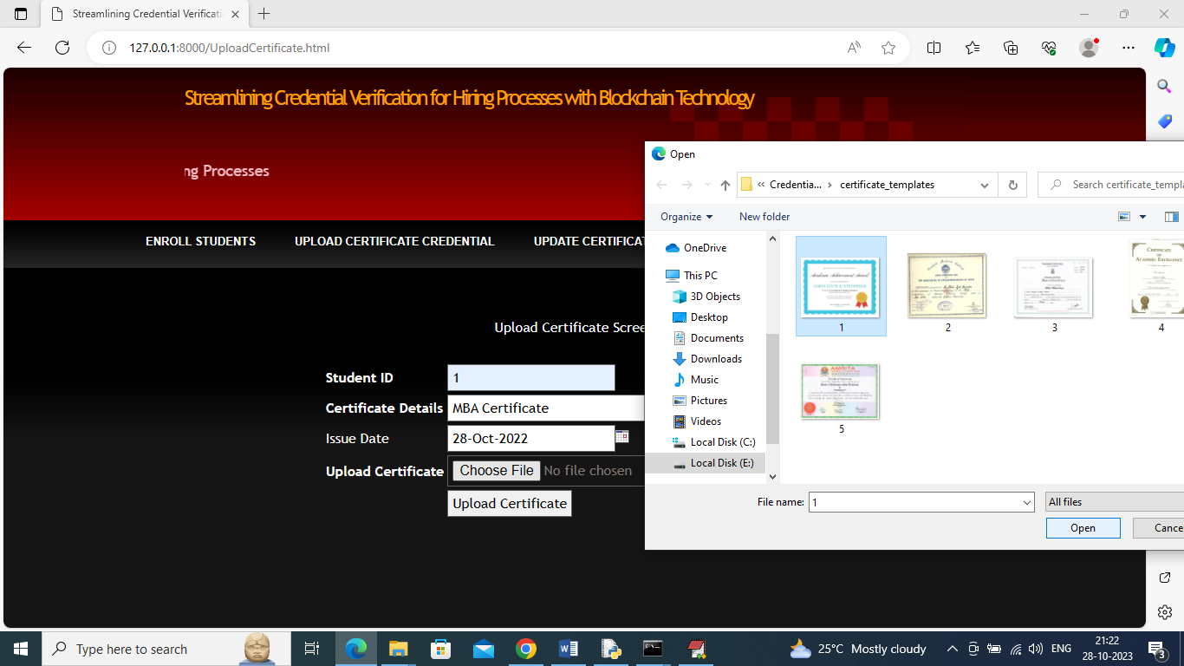

In above Screen University is uploading certificate for student ID 1 and then press button to save certificate in Ethereum

**FIG 12:**

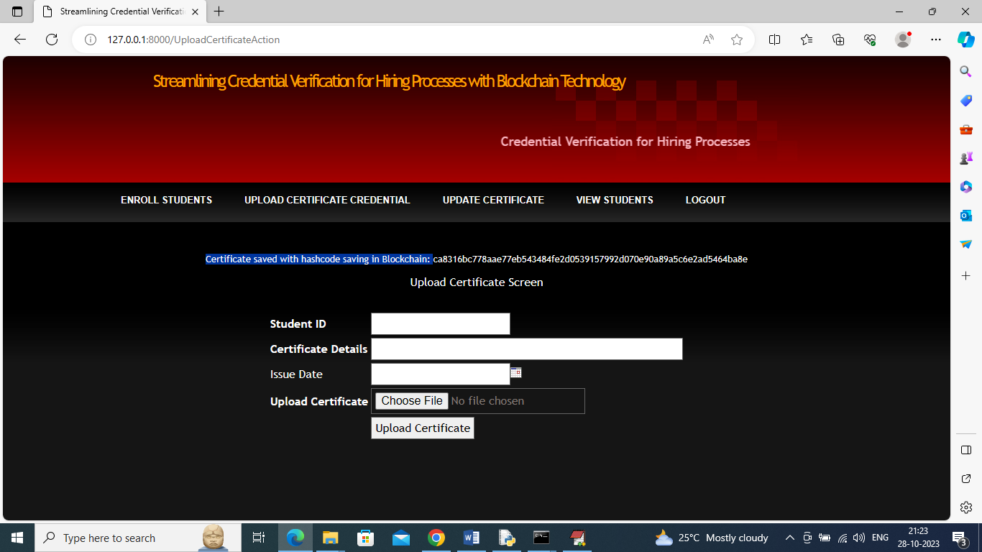

In above screen in blue colour text we can see certificate saved in Blockchain with displaying hashcode and under same student we can upload multiple certificates of different courses

**FIG 13:**

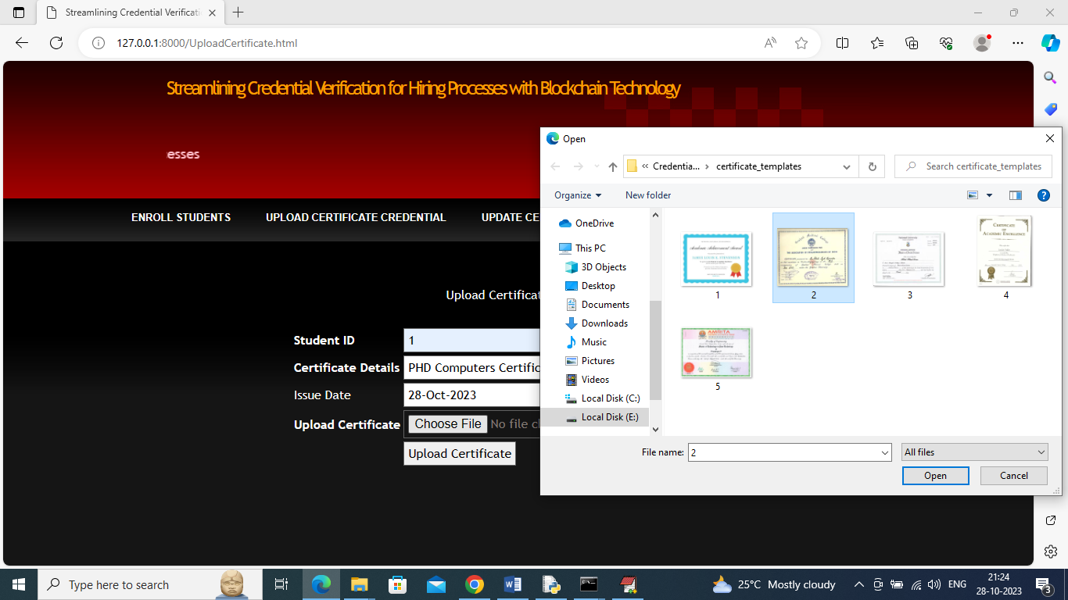

In above uploading another PHD certificate for same student and then press button to get below page

**FIG 14:**

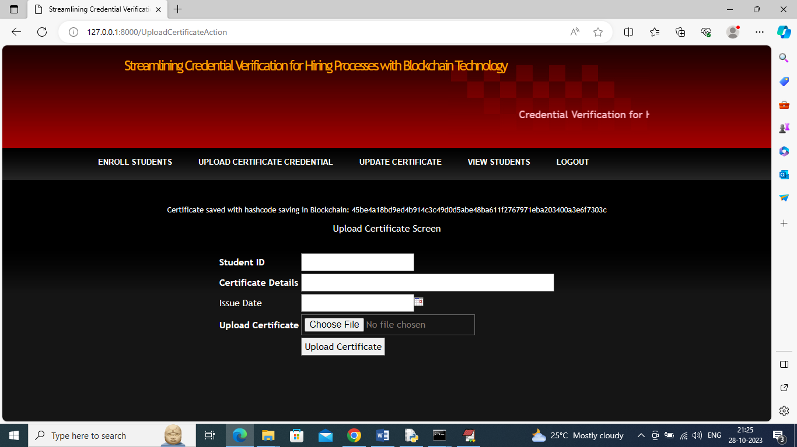

In above screen certificate details saved and now in above screen click on ‘Update Certificate’ link to upload certificate for same student if changes required in certificate

**FIG 15:**

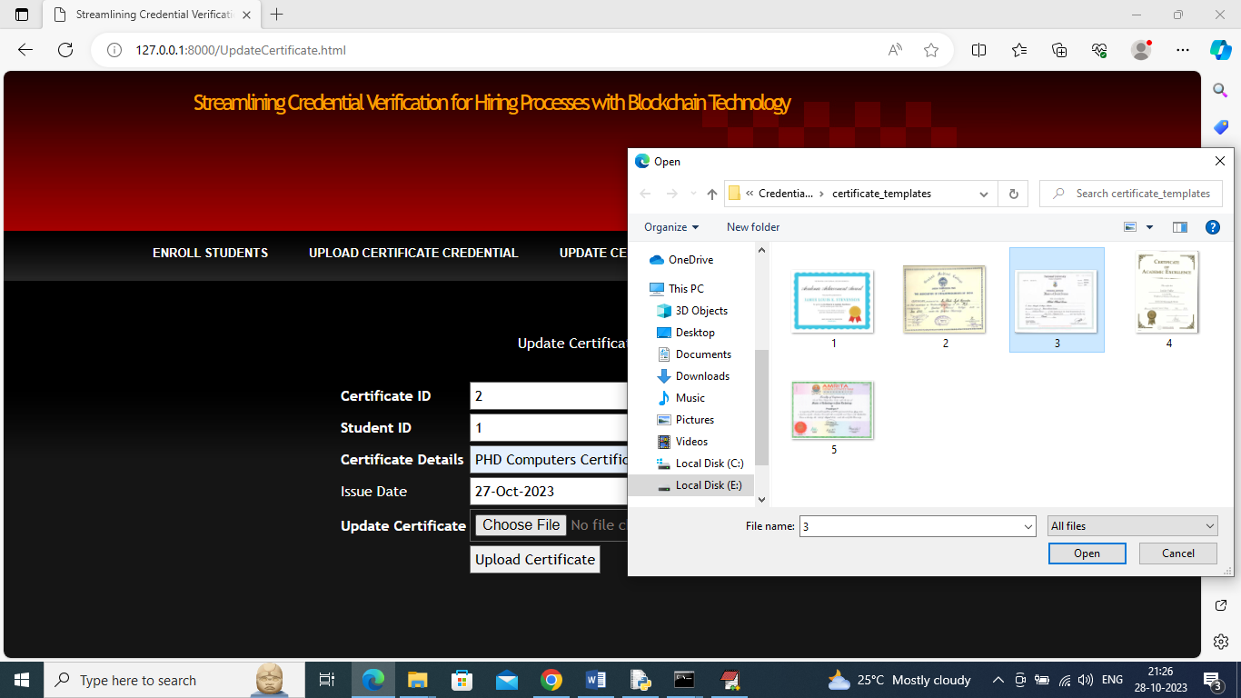

In above screen entering certificate and student id and then uploading modified certificate to make changes and get below screen

**FIG 16:**

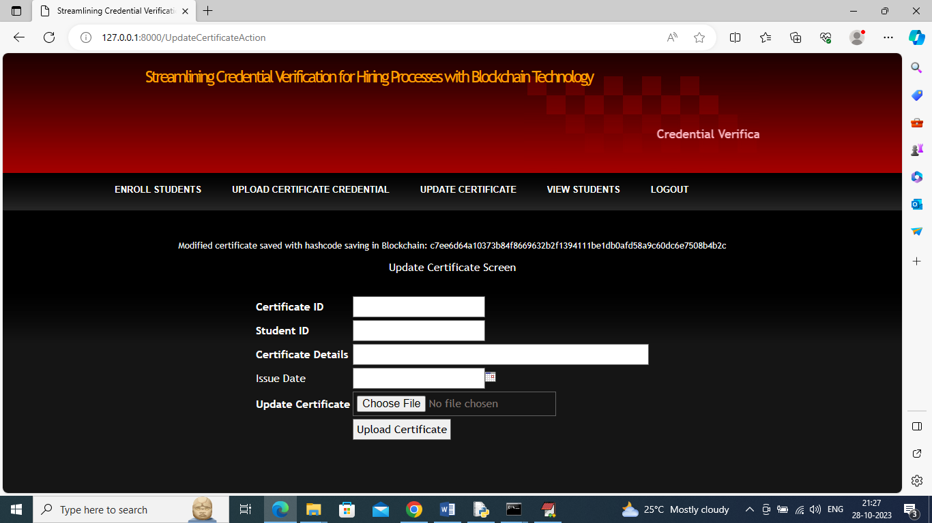

In above screen modified certificate saved in Blockchain and now click on ‘View Students’ link to view all student details

**FIG 17:**

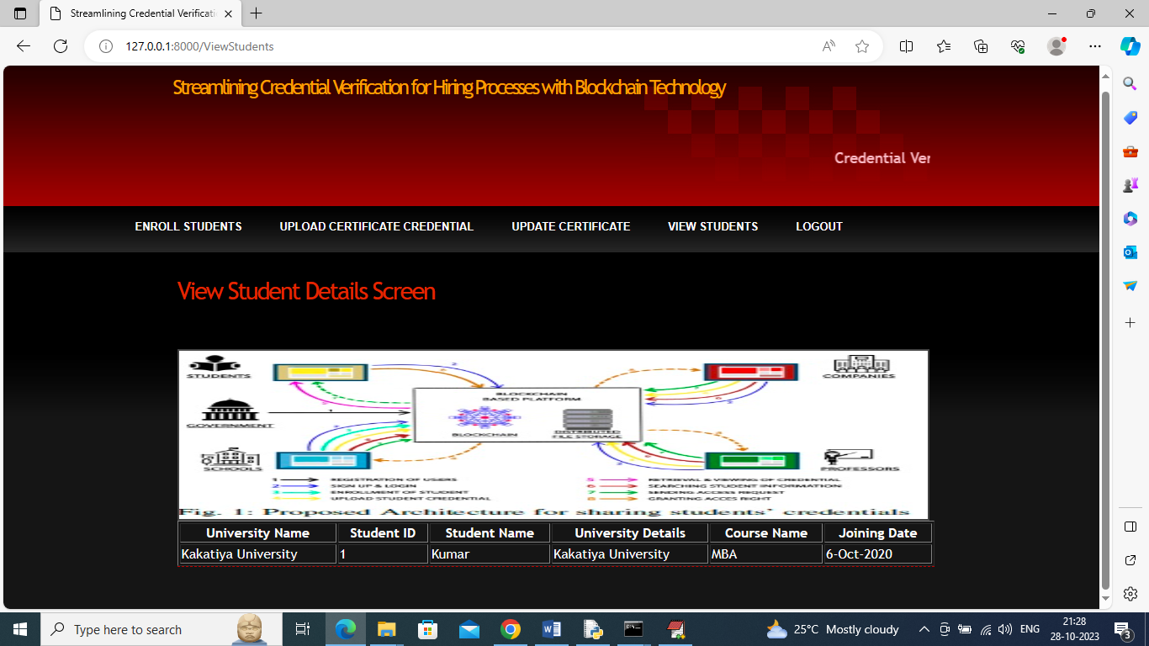

In above screen in tabular format we can see student details and now click on ‘Logout’ link and then login as company

**FIG 18:**

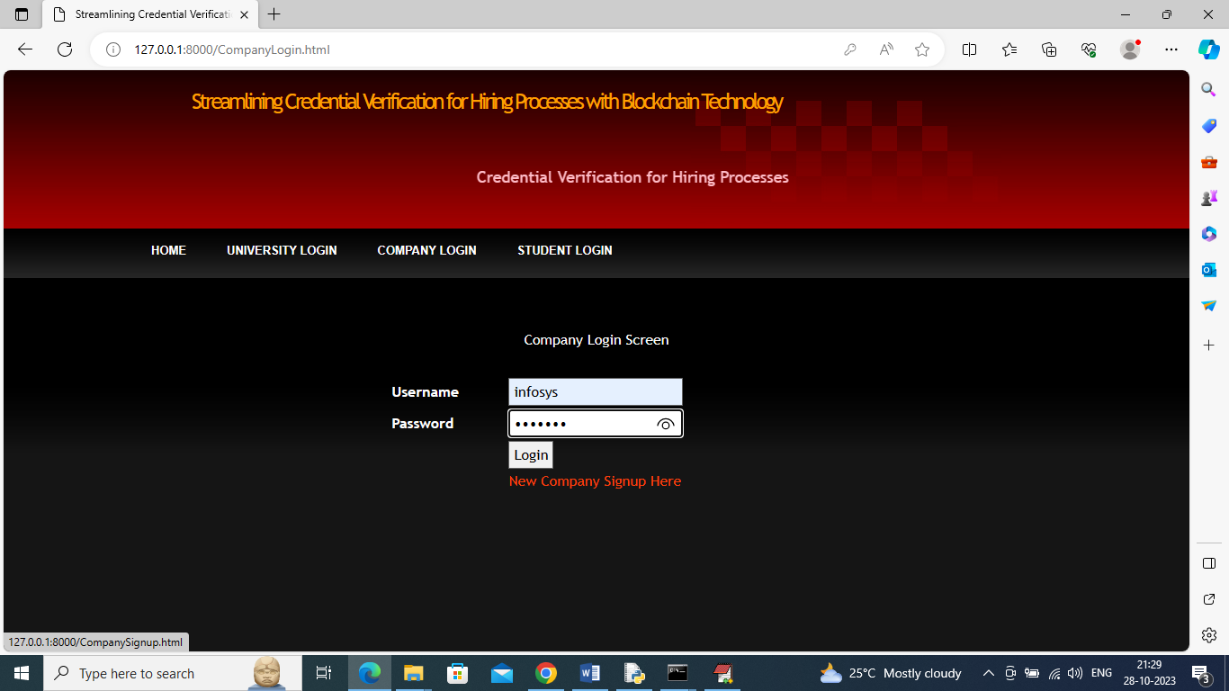

In above screen company is login and after login will get below page

**FIG 19**

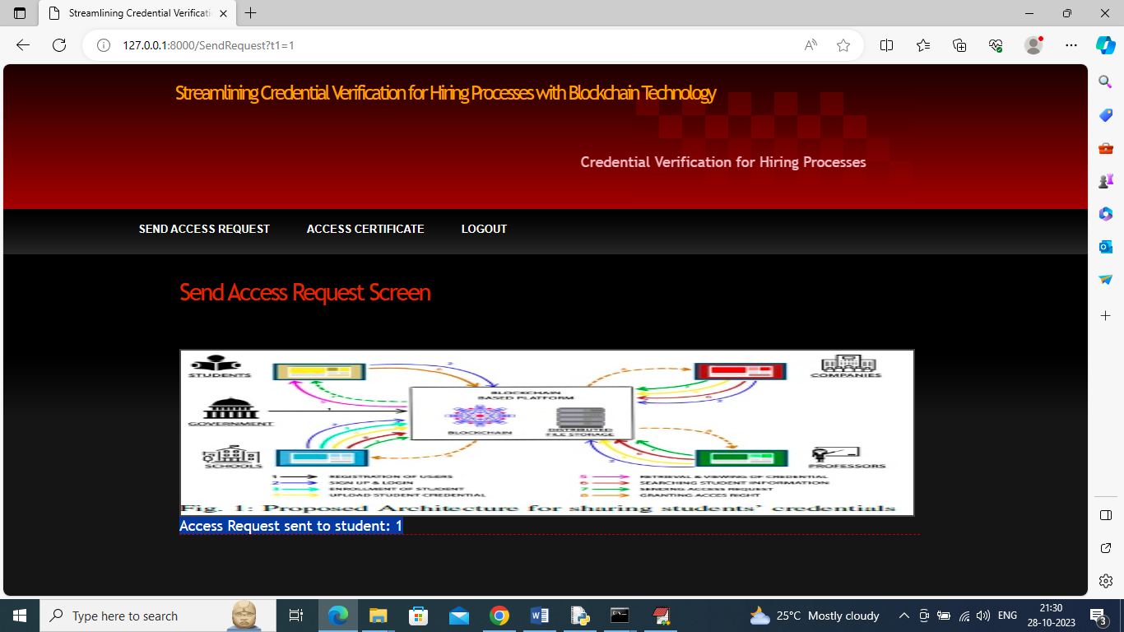

In above screen company can view all student and their course details and then click on ‘Click Here’ link to send access request to that student

**FIG 20:**

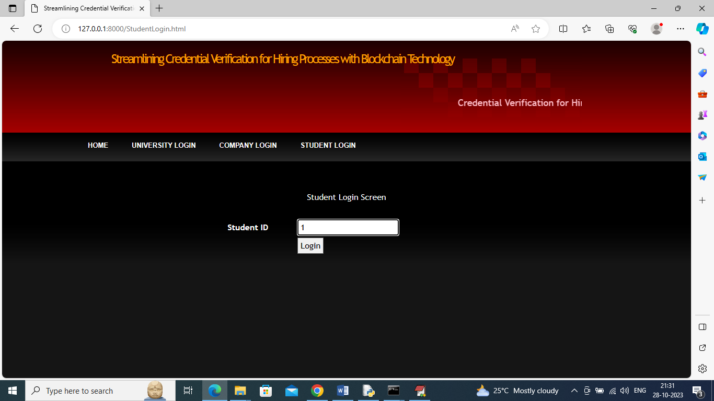

In above screen student is login by using his ID and then press button to get below page

**FIG 21:**

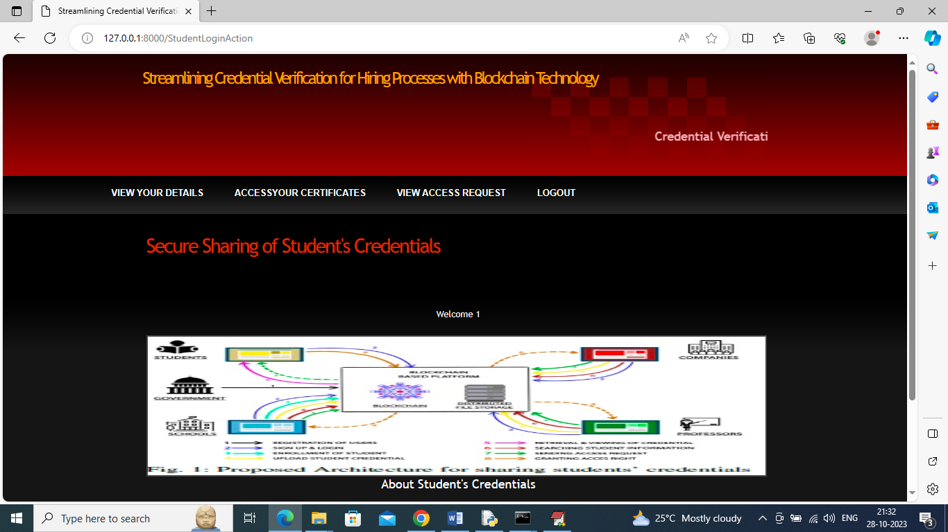

In above screen student can click on ‘View Your Details’ link to view their course details

**FIG 22:**

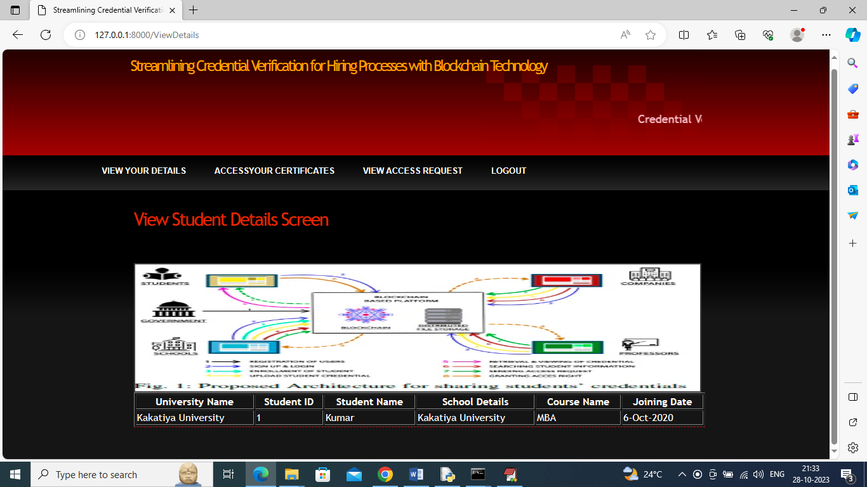

In above screen student can view his details and now click on ‘Access Your Certificate’ link to view their certificates like below screen

**FIG 23:**

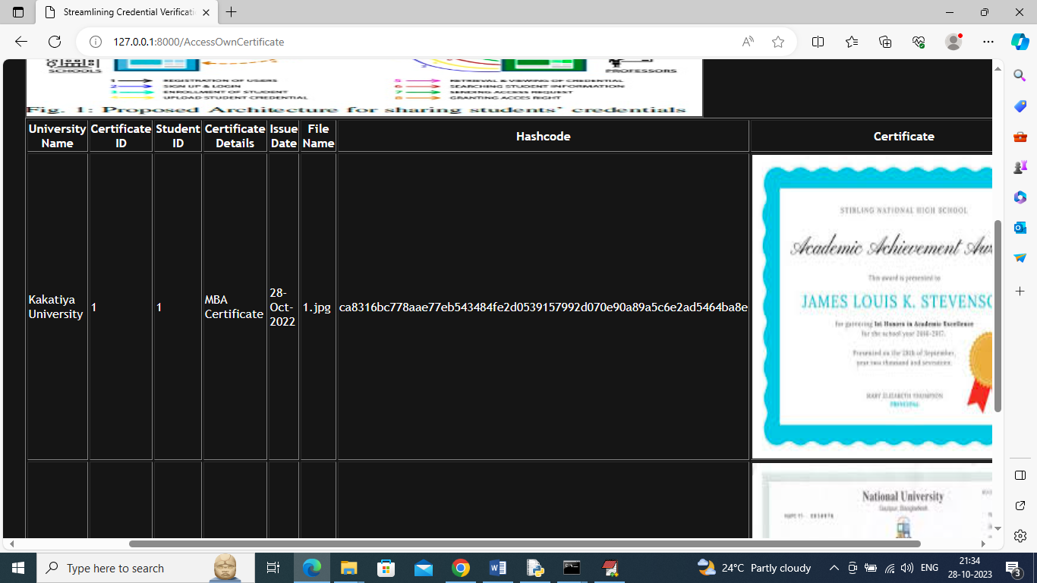

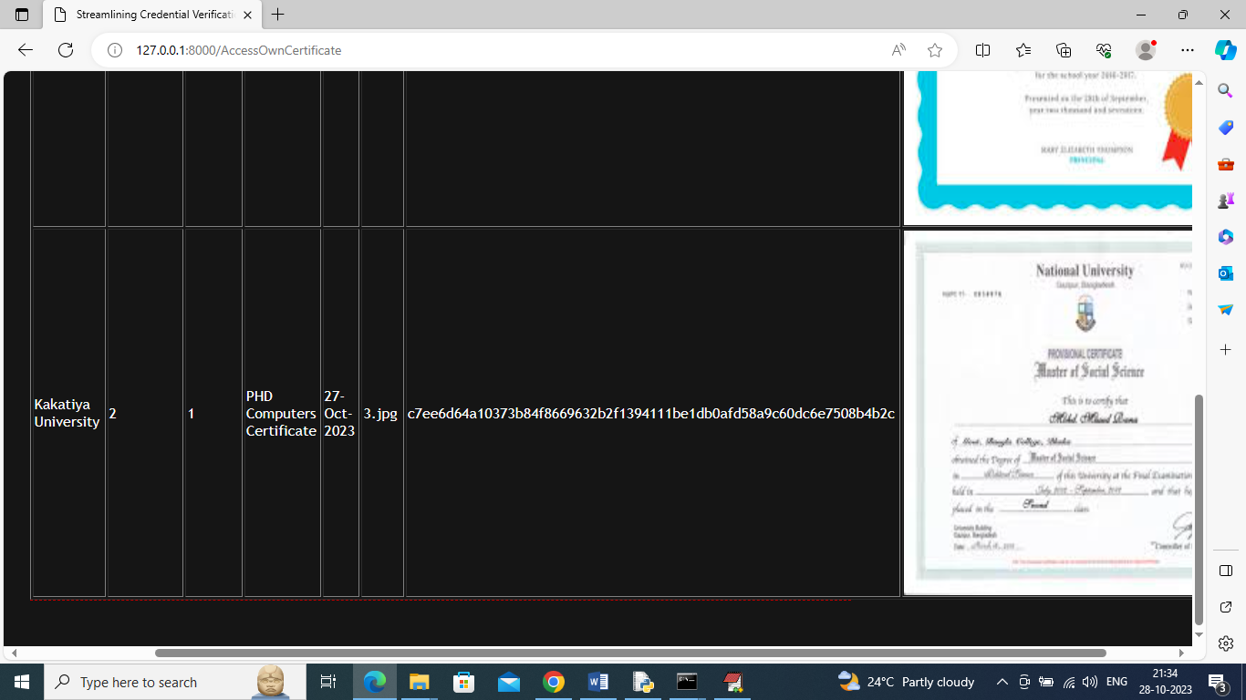

In above screen student can view all his certificates and now click on ‘View Access Request’ link to view request from companies

**FIG 24:**

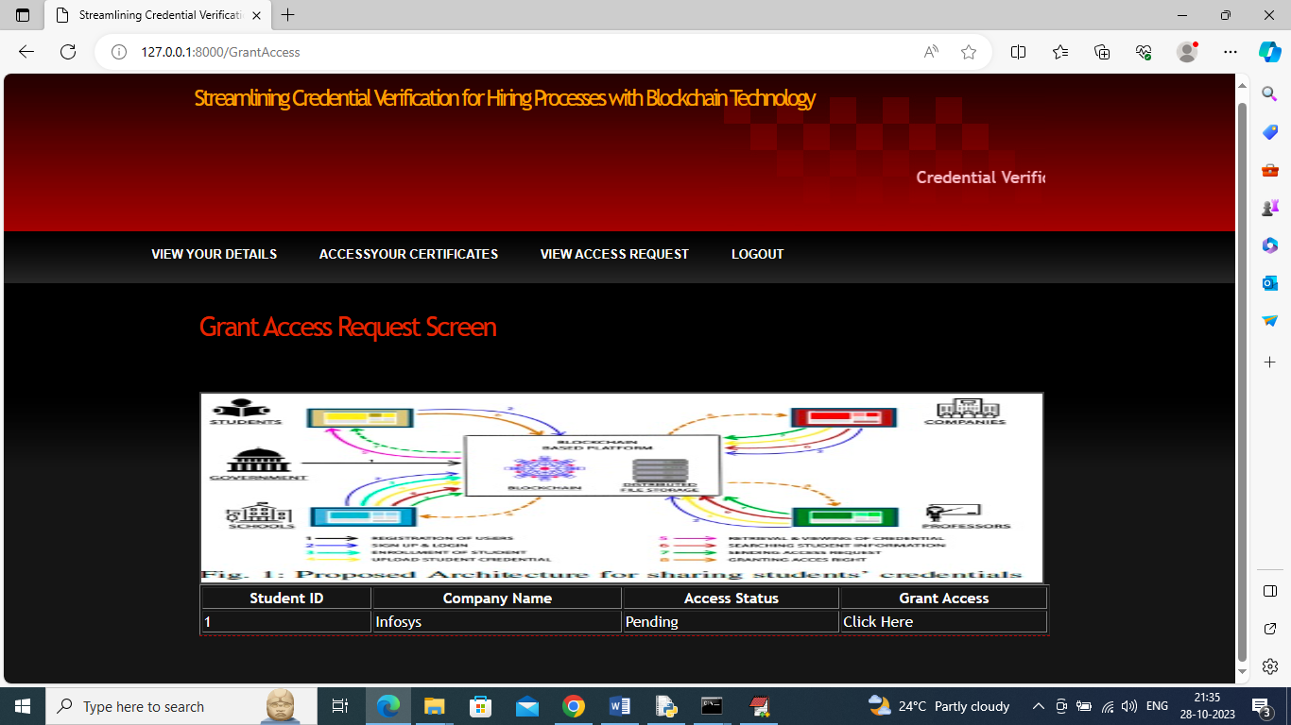

In above screen student can view company details and then click on ‘Click Here’ to approve request and get below page

**FIG 25:**

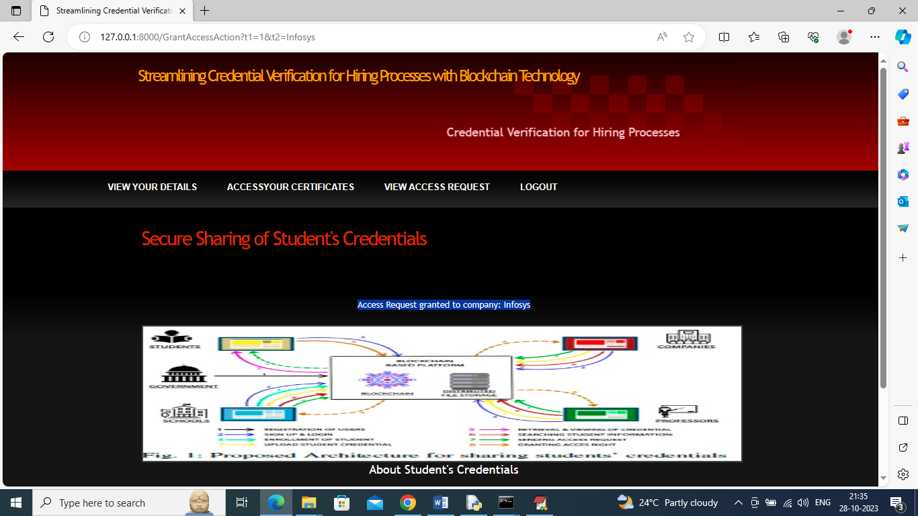

In above screen in blue colour text we can see Access Request Granted for given company and now logout and login as company so company can access granted certificates

**FIG 26:**

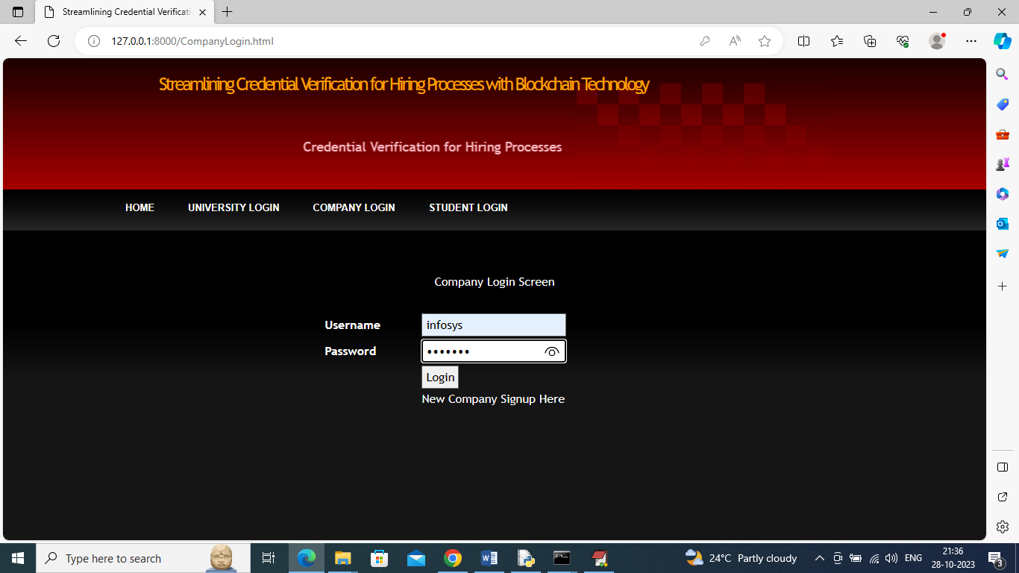

In above screen company is login and after login will get below page

**FIG 27:**

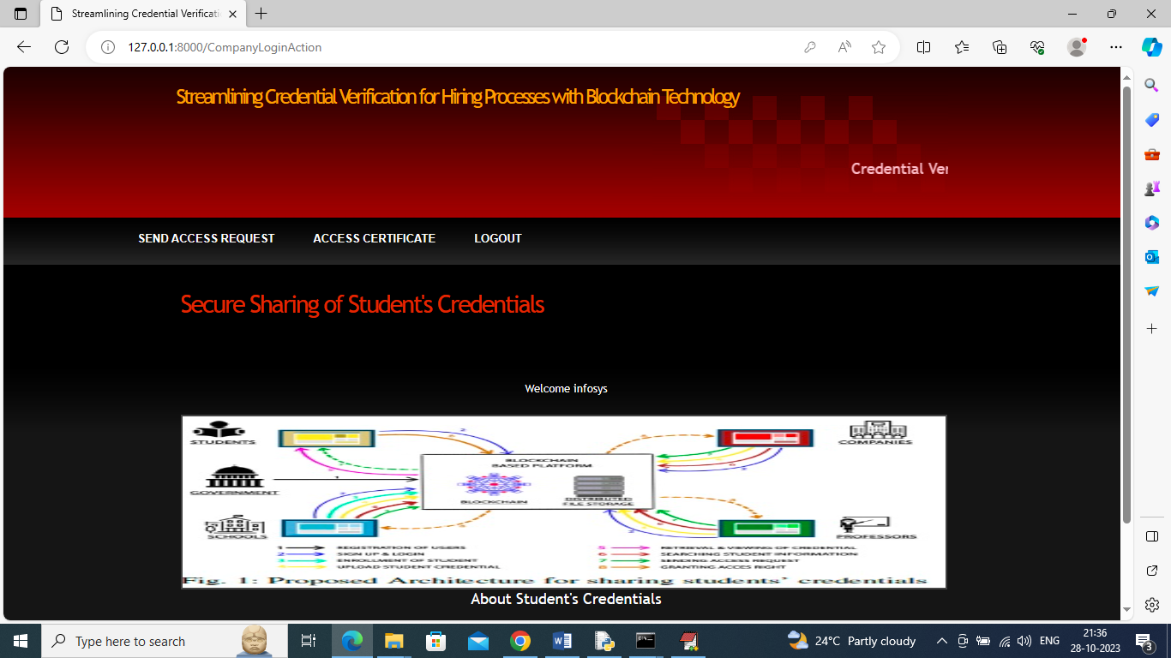

In above screen company can click on ‘Access Certificate’ link to view access granted certificates

**FIG 28:**

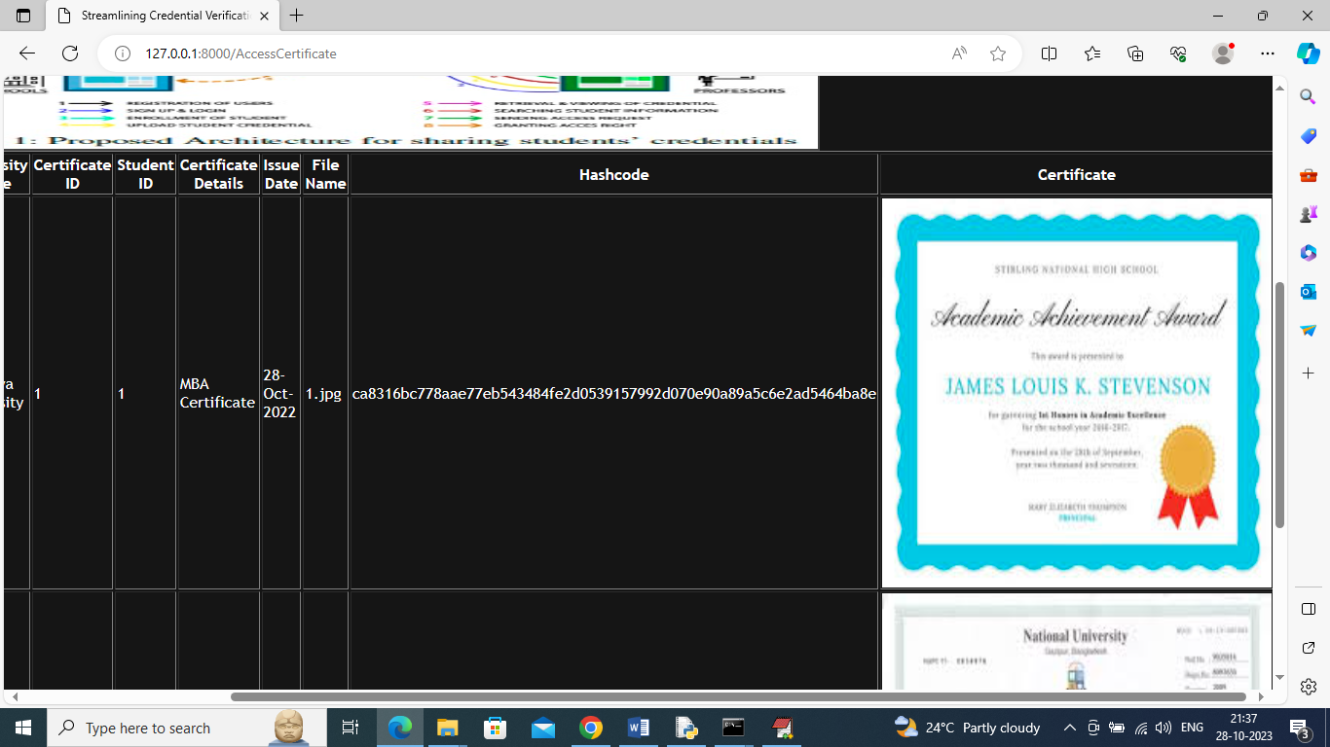

In above screen company can view all certificates of all students

Similarly by following above screens you can upload any number of student credentials to Blockchain